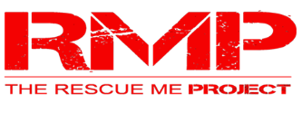
The Rescue Me Project Mega Center Fund Raising Campaign

The Rescue Me Project was established as a 501 (c) 3 not-for-profit organization with the purpose of providing a safe haven where underserved youth can participate in a comprehensive program of mentoring and academic tutoring that promotes the physical, educational and life skills necessary to prepare them for leadership in their communities and success in their personal lives.

We have found that there is a tremendous need for programs that provide activities and support for children during school, after school, and throughout the summer. We are aware of the crime, truancy, substance abuse, obesity, teen pregnancy, and academic failure that is prevalent within the demographic we serve. But, The Rescue Me Project is playing a big part in their transformation.

The Rescue Me Project has acquired the former Southwest Elementary School building in Sheffield, AL for the purpose of offering structured programs to encourage and empower young people by providing life skills mentoring that promotes positive values, healthy habits, and education success.

We are embarking on a Fund Raising effort to transform our new facility into a place that will provide opportunity and pride throughout the community.

Our goal is $175,000.00 for a new roof and new windows, plus other items to create a facility that will serve the youth of the Shoals and Tri-County area, ensuring that they will get what they need to become productive citizens.

With our gratitude, here’s how you can help:

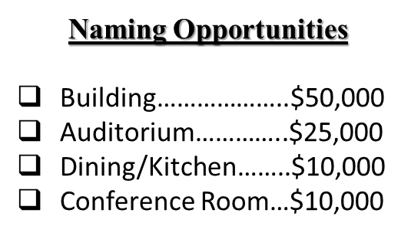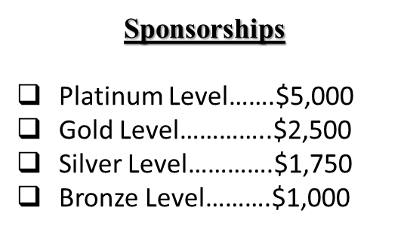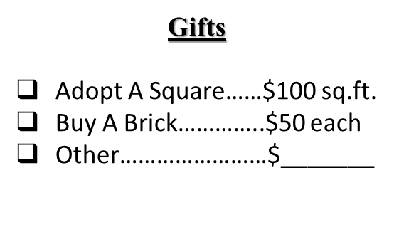
Naming Opportunities (*subject to RMP board approval) -The opportunity to have your name designated with the building or a space within the building, means that you will be mentioned every time the building or the space is mentioned or utilized. This will create a powerful impact for you or your business within the community. This naming opportunity is more than a plaque on a building. It shows a commitment to the community, and creates a profound legacy.

Sponsorships – All sponsors will have their name(s) displayed in a place of honor for all to see. Sponsors names will be included on a plaque at a prominent place designated within the building or placed near one of the classrooms. Sponsors name and/or Logo will be included on the RMP Website, and/or Monthly Newsletter. We are also considering a wall mural (to be determined), which will include the names of our sponsors. Sponsors will be recognized at program events, assemblies, and programs.

Gifts – The RMP appreciates all gifts. Our new mega center has over 14,000 square feet. You may adopt a square foot for $100 per square foot. You may also buy a brick/paver for our proposed walkway for $50 each.

Your gift is a sacred trust. We promise to honor your generosity and use your donation in the most effective way possible. All contributions are tax deductible.

Donations can be made to:

The Rescue Me Project – 1300 S.W. 8th St. – Sheffield, AL 35660

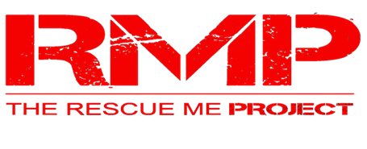
The Rescue Me Project Mega Center Fund Raising Campaign

“LET’S RAISE THE ROOF”
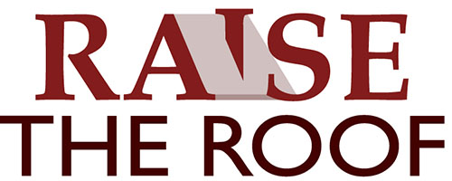

$175,000

$140,000

$105,000

$70,000

$35,000

$0
